Normal Distribution:

pdf: 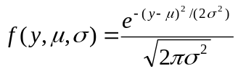
cdf: No simple explicit expression

Mean = 
Variance =

likelihood = 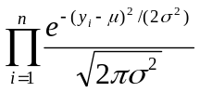

loglikelihood = 
